SimCell
- Java application that uses DCA at the meso-scale

Within the grid each object or molecule occupies a square, typically measuring 3 nm on a side. The choice of 3 nm as the standard grid increment is based on a number of criteria.

The diameter for an average protein is approximately 3 nm,
The average width of a cellular membrane is approximately 3 nm,
The average width of a supercoiled DNA molecule is about 3 nm
The average velocity of a macromolecule in a cell is approximately 3 nm per millisecond

ABM vs EBM

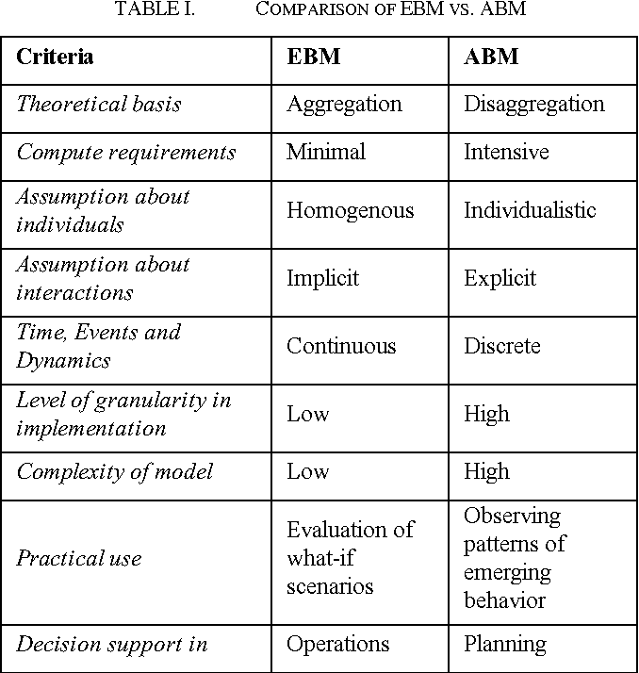

Advantages of ABM | Advantages of EBM
Allows for divergent behaviour and therefore, we can use ensemble modeling to discover probability of negative outcome. | Several intuitive drag-and-drop tools for constructing and analyzing system dynamics models exist (Stella, Powersim, Simulink (of Matlab) or VENSIM) which makes EBM relatively easy to use
Burn wound healing is inherently spatio-temporal as: depth of damage is non-linear, systemic immune response only valid where there is bloodflow, wound can only heal from edges first,
Skin tissue is a highly layered (heterogenous) medium

EBM
- EBM tends to focus the modeler’s attention on the overall behavior of the system. Its basic constituencies are levels and flow rates, and not so much individual components.
- EBM is primarily validated on the systems level by comparing model output with real system behavior. Since behavior of individual components is not explicitly in its focus, it usually is not validated on this level.
- Furthermore, EBM (when restricted to ODE-methods like System Dynamics) has no intrinsic option for representing space (PDEs provide parsimonious options for modeling physical space, but not the interaction space of individual agents).

ABM
- Like EBM it allows to compare model output with observed system behavior. Additionally however, it can be validated at the individual level by comparing the encoded behavior of each agent with the actual behavior of real agents. This however, usually requires additional data and hence more efforts in empirical research.
- ABM allows representing space, thereby offering possibilities to consider topological particularities of interaction and information transfer.

